There are 2 ways of representing dataset:

First:

In this we represent each column as a feature(f1, f2, ……, fd) and each row as datapoint,

So we can say each row is xiT that means transponse of xi, where xi = [SL, SW, Pl, PW] for iris, and since we represent it as column vector and to convert it into row vector we take transponse of it.

Y is a column vector of dimension n\*1, where each y or yi is the class label or result of xiT. Example for iris for any xi, yi is one of the { Setossa, versicolor, virginica}.

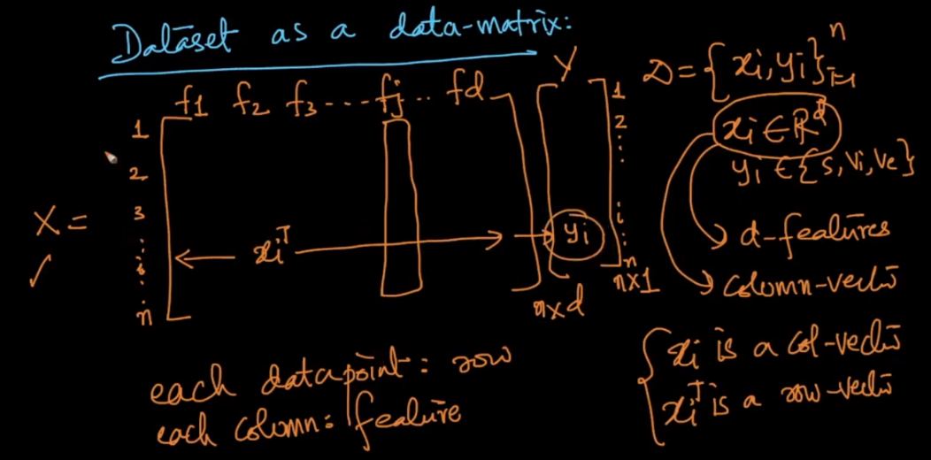

pto

Second: In this we specify each row as feature and each column as datapoint, that means we arrange each xi in n columns (since xi is column vector), for example for iris we have rows as SL,SW,Pl,PW and there will be 150 columns. It’s found in most of the research papers.

